|  |
| --- |
| Heriot-Watt University |
| Project Success |
| C11PS_2016/2017 |
|  |
| **Iyaka, Beni H00181266** |
| **15. November. 2016** |

Table of Contents

The Case 2

1. About Dar Al Handasah 2

2. Business Case of Dar Al Handasah 3

3. Dar Al Handasah case studies in Dubai 4

3.1 How do they define project success? 4

3.2 What affect Project Success? 6

4. The Effect of IT in Dar Al Handasah Group 7

5. How Dar Al Handasah Group measures project success 7

# The Case

## About Dar Al Handasah

Dar Al Handasah Group is a privately owned international professional service which is supported by various brands of specialist that are dedicated to the planning, designing, implementing, project management of facilities, installations and structures that help with the sustainability of communities worldwide.

Dar Al Handasah Group has offices in Beirut, Cairo, London, Pune, Amman, Chicago, San Francisco, Hong Kong, Taipei, Singapore, Paris, Cincinnati, Liz, St. Louis, Johannesburg and Vicenza. Dar Al Handasah Group has over 18000 employees operating from a total of 193 offices and 58 countries spanning the Americas, Europe, Australia, Middle East, Africa and Asia. (Dar, 2016)

In the Middle East, Dar Al Handasah Group has been operating since the mid-1950s in the field such as planning, designing, engineering and project management. Since then, Dar Al Handasah Group has accomplished notable projects such as Beirut Central District, Four Season Hotel in Damascus and the Jordan Valley Irrigation Project. (Dar, 2016)

Dar Al Handasah Group acknowledges the usefulness of tangible and intangible benefits of projects or programs so as to achieve project success. Therefore, they use those approaches to analyze project success. (Dar, 2016)

## Business Case of Dar Al Handasah



Business Case is one of the decision-making tools used to identify the effect of specific decisions to benefit and project success. Business Case should define components used for calculations of the project particularly the cost and assumption so that they should have a better understanding of benefits. Business case also provides the record and road map which allows the workers to claim all the benefits identified from a project and also helps the management team to follow up on the actual and the expected benefits so as to guarantee the success of a project. (Angeline, 2011)

In order for a team to define a project as a success, a well-formatted Business Case should be established by answering the "WHY" question, analyzing the decisions, analysis changes and plan a project closure.

Business Case acts as the source of the final presentation while getting approval from the senior management team to start with a particular project. It breaks down the current benefits so that they should be well measured and compared to any benefits claimed as recommendations related to a various business process implemented.

Dar Al Handasah Group defines a project as success if:

* The desired outcome is met.
* The organizational needs and market needs are met.
* The quality requirements are met.
* Meet the Scope demands.
* Project was executed on schedule and within the planned budget.

In order to make Dar Al Handasah Group control their projects and make them successful, the senior management team focuses on feasibility studies, Key Performance Indicator, Risk Analysis and Cost Analysis so that they should thoroughly evaluate success criteria of the project.

## Dar Al Handasah case studies in Dubai

### How do they define project success?

Dar Al Handasah Group is a worldwide construction company with a headquarters based in Beirut. For this report, we will look at the Dubai extension and analyze how they define project success.

The Dubai extension defines project success based on 3 areas which are:

#### Benefit realization

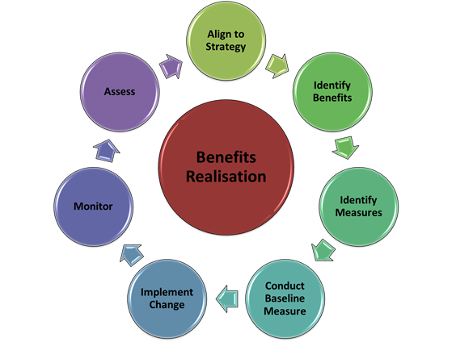

This is a process of identifying, tracking; realizing and optimizing the benefits ensuring that the target set by the organization for a specific project are met.

#### Project delivery

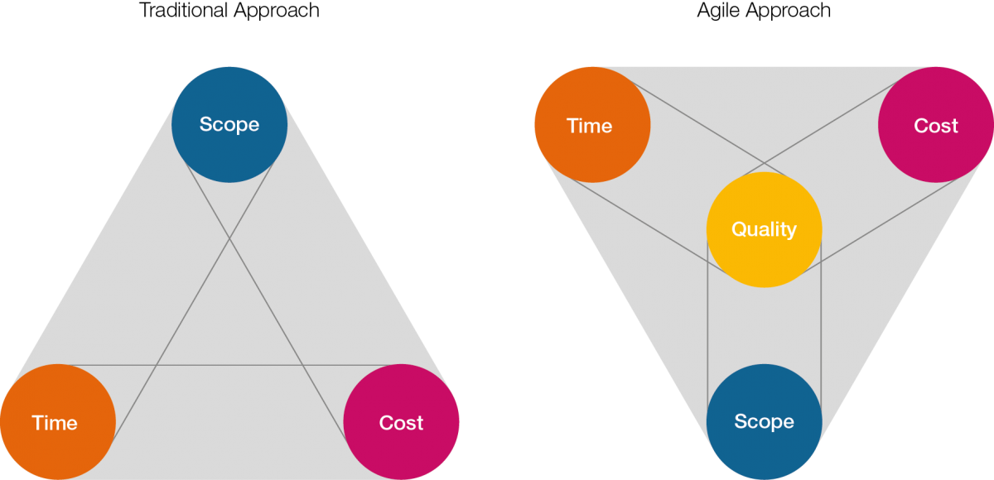

This is a process of analyzing the project based on time, budget, quality and scope.

#### Organizational project capabilities

Since Dar Al Handasah Group runs many projects, the past successful projects also increase the confidence maturity and capabilities of the company to also deliver other projects successfully.



### What affect Project Success?

As said in the previous section, before every success story, there is a good planning and a failing story behind it. Looking at Dar Al Handasah Group, they have defined some various aspects that affect project success. In this section, we will discuss them.

#### Poor preparation

With the growing demand in Dubai, clients tend to force an organization to do everything in a hurry; therefore, to prevent that, Dar Al Handasah Group uses a mechanism that allows them to get concrete information by having lengthy meetings with stakeholders to discuss their expectations on cost, time and quality of the project.

#### Inaccurate cost estimation

With high demand for resources in Dubai, They may be a stage in the project whereby resources run out and the project stops until resources will become available again.

To prevent such situations from happening Dar Al Handasah Group tries to identify lack of resources at an early stage as possible so that they should be on the safe side in case the resources run out.

#### Competing Priorities

This usually happens when they are not enough resources; therefore they will be competition for personnel, resources and founding.

To prevent such problems, Dar Al Handasah tries to have good cost estimation at the start of the project.

## The Effect of IT in Dar Al Handasah Group

Technology in our days has helped many organization improve their and vision. Ways of operating. In this section, we will be discussing what effect technology has on Dar Al Handasah Group.

#### Pre-fabrication

With the help of the IT department, Dar Al Handasah Group is able to assemble the building component off-site so as to have a prototype of what is required from them. By doing so:

* Cost efficiency is increased.
* Less material and energy is wasted.
* Time Saving.
* Decrease the risk of pollution.

## How Dar Al Handasah Group measures project success

In some companies, a team can start a project without having success criteria and this usually does not end well.

In Dar Al Handasah Group, they have 6 factors that help them measure project success.

#### Schedule

A project cannot be successful without deadlines. Always try to set deadlines for a project either if the client just wants a final product; by doing so, the project is well managed and has a high chance of being completed within the set schedule.

#### Scope

This is part of the project planning stage. This focuses on identifying and documenting specific goals, deliverables, features, functions tasks, deadlines and the overall cost of the project. In other words, this is setting up time frames for everything that needs to be done.

#### ***Budget***

This aspect is known to be the most important factor of any project. Dar Al Handasah Group tries to maintain their project budget by letting the team know where they stand in term of money spent. Before they start a certain project, the client is given a quote; the organization will make sure that stick to it.

#### Team Satisfaction

This is a factor that is usually overlooked in most projects.

In Dar Al Handasah Group, they make sure that everyone who is involved with the project should be satisfied. By doing so, if a team is required to work late on a project, they will do it without any disapproval.

To keep their team satisfied, interviews and questionnaires based on the teamwork, management issues, work content and results are performed in all the phases of the project.

#### Customer Satisfaction

This is a factor that looks to see if the client is satisfied with either the evolution of the project or the final product of the project.

In Dar Al Handasah Group, in order for them to evaluate customer satisfaction, the organization has developed six questions that they analyze throughout the project. These questions are:

* Are we meeting the customer's expectations?
* How has the customer input being in the project?
* How much effort do customers spend while solving solve their problems with us?
* What are our chances on being recommended by our customers to their colleagues?
* How do we define our workload?
* What are the customer activities been like in the project?

#### Quality of work

This is known to be one of the most important factor to measure project success. But it is also very difficult and time-consuming factor to perform because it involves finding the suitable words and expressions as well.

It involves the evaluation of the team, client and everything else involved with the project.

In Dar Al Handasah Group, Quality of work is evaluated through:

* Analysis of strength and weaknesses of people involved with the project.
* Asking people to comment on the areas of concern.
* Analyzing employee’s comments.
* Analyzing employees’ job performance in relation to their personal goals.
* Thinking of performing training if the bar is too low.

# Bibliography

Angeline, 2011. *Project Management beta.* [Online]   
Available at: http://pm.stackexchange.com/questions/3122/definition-of-project-success  
[Accessed 10 November 2016].

Dar, 2016. *About.* [Online]   
Available at: http://dar.dargroup.com/about/overview  
[Accessed 10 November 2016].

De Wit, A., 1988. Measurement of project success. *International journal of project management*, *6*(3), pp.164-170.

Gray, R.J., 2001. Organisational climate and project success. *International journal of project management*, *19*(2), pp.103-109.

Jugdev, K. and Müller, R., 2005. A retrospective look at our evolving understanding of project success. Project Management Institute.

Müller, R. and Turner, R., 2007. The influence of project managers on project success criteria and project success by type of project. *European Management Journal*, *25*(4), pp.298-309.

Nelson, R.R., 2005. Project retrospectives: Evaluating project success, failure, and everything in between. *MIS Quarterly Executive*, *4*(3), pp.361-372.